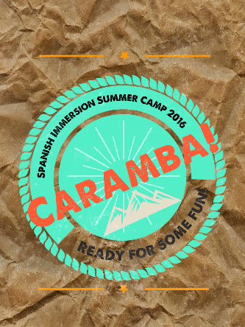

**Caramba Spanish Immersion Camp**

The Caramba Spanish Immersion Summer Camp is a program that will give your child a chance to actively learn and interact with others in Spanish. We have a terrific curriculum in place. We sing, dance, cook, paint, read stories, and play games with kids, all in Spanish! Our Spanish speaking teachers will be teaching your child each week!

**Students must be fully potty trained and at least three years old by May 31, 2016.**

• Camp hours are 9:00am- 12:00pm.

• The cost of each session is $175.00 (current full-day student – rate $100 in addition to weekly tuition)

• Morning snack is provided to all campers.

To register for Spanish camp, simply return a one-time $30.00 non-refundable Registration fee with the registration form below***.*** Students new to Open Arms must also complete a registration form. Camp fees will be billed upon enrollment.

**Tuition Responsibility**: Full payment is due the first day of each session. Full tuition is due if a camp is NOT cancelled 5 business days in advance.

**Child’s Name________________________________________ Date of Birth__________­­_________________**

**Parent’s Names______________________________________ Phone number_________________________ __**

**Email address_________________________________________________________________________________**

**Please check the camps that you would like to register your child for.**

**_____ Session 1** (7/11-7/15) “Colombia”

**_____ Session 2** (7/18-7/22) “Mexico”

**_____ Session 3** (7/25-7/29) “Peru”

**_____ Session 4** (8/1-8/5) “Cuba”

**\*\*Students not currently enrolled in Open Arms must also submit an enrollment registration form\*\***

**Office Use Only**

Date submitted:_________ Rec’d by:_____________ Reg fee paid $_______ Date:______________